BIT3208: Advanced Web Design and Development

STUDENT DETAILS
Student Name: Wango Douglas Maina
Admission Number: BSCCS/2024/53915
Course/Class: Computer Science
Unit Code: BIT3208
Unit Name: Advanced Web Design and Development
Lecturer Name: Nyoro Michael
Semester/Academic Year: 3.2

PROJECT DETAILS
Project Title: Smart student attendance system

Selected Technologies:
- HTML – Structure and markup of all system pages
- CSS – visual aesthetic and responsive layout design
- JavaScript – Client-side interactivity event handling and dynamic DOM manipulation
- PHP – Server-side processing business logic and json API management
- MySQL – Relational database for persistent data storage
- XAMPP – Local cross platform development server environment
- VS Code – Primary code editor and intergrated development environment

ONLINE PORTFOLIO / GITHUB LINK
GitHub Repository Link: https://github.com/thee-mask/attendance-System

Table of Contents

Table of Contents

Week 1: Local Environment Setup.............................................. 1
Title........................................................................
Required Evidence.................................................
Student Reflection..................................................

Week 2: Wireframes and GUI Design........................................... 2
Title........................................................................
Required Evidence...................................................
Student Reflection...................................................

Week 3: JavaScript and PHP Basics.............................................. 3
Title........................................................................
Required Evidence....................................................
Student Reflection.........................................................

Week 4: Server-Side Components.................................................. 4
Title........................................................................
Required Evidence.......................................................
Student Reflection.........................................................

Week 5: Database Components.................................................. …..5
Title........................................................................
Required Evidence............................................................
Student Reflection...........................................................

Week 1: Local Environment Setup

Title
Installation and Testing of Local Development Environment

Required Evidence
- Fig 1: XAMPP installation wizard completing successfully.
SCREENSHOT
- Fig 2: XAMPP Control Panel showing both Apache and MySQL modules with green status indicators, confirming both services are running and ready to serve requests.
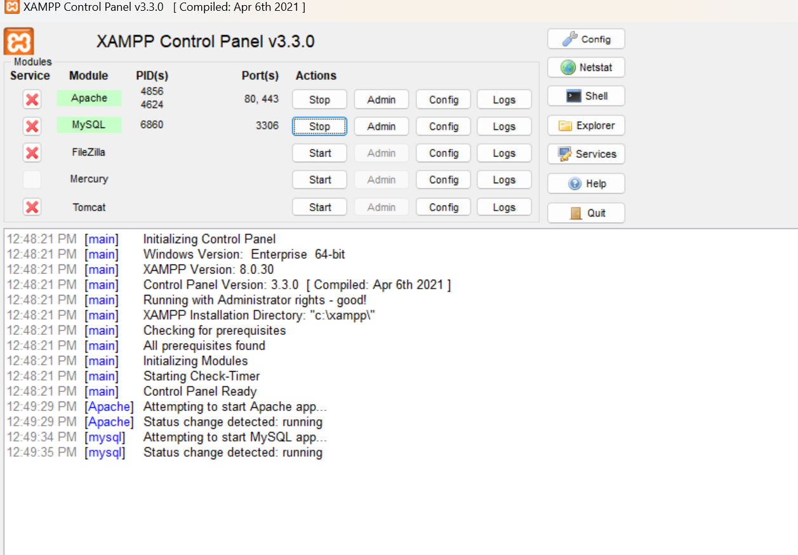
- Fig 3: Browser displaying the XAMPP localhost welcome page at http://localhost, confirming that the Apache server is correctly configured and accessible.
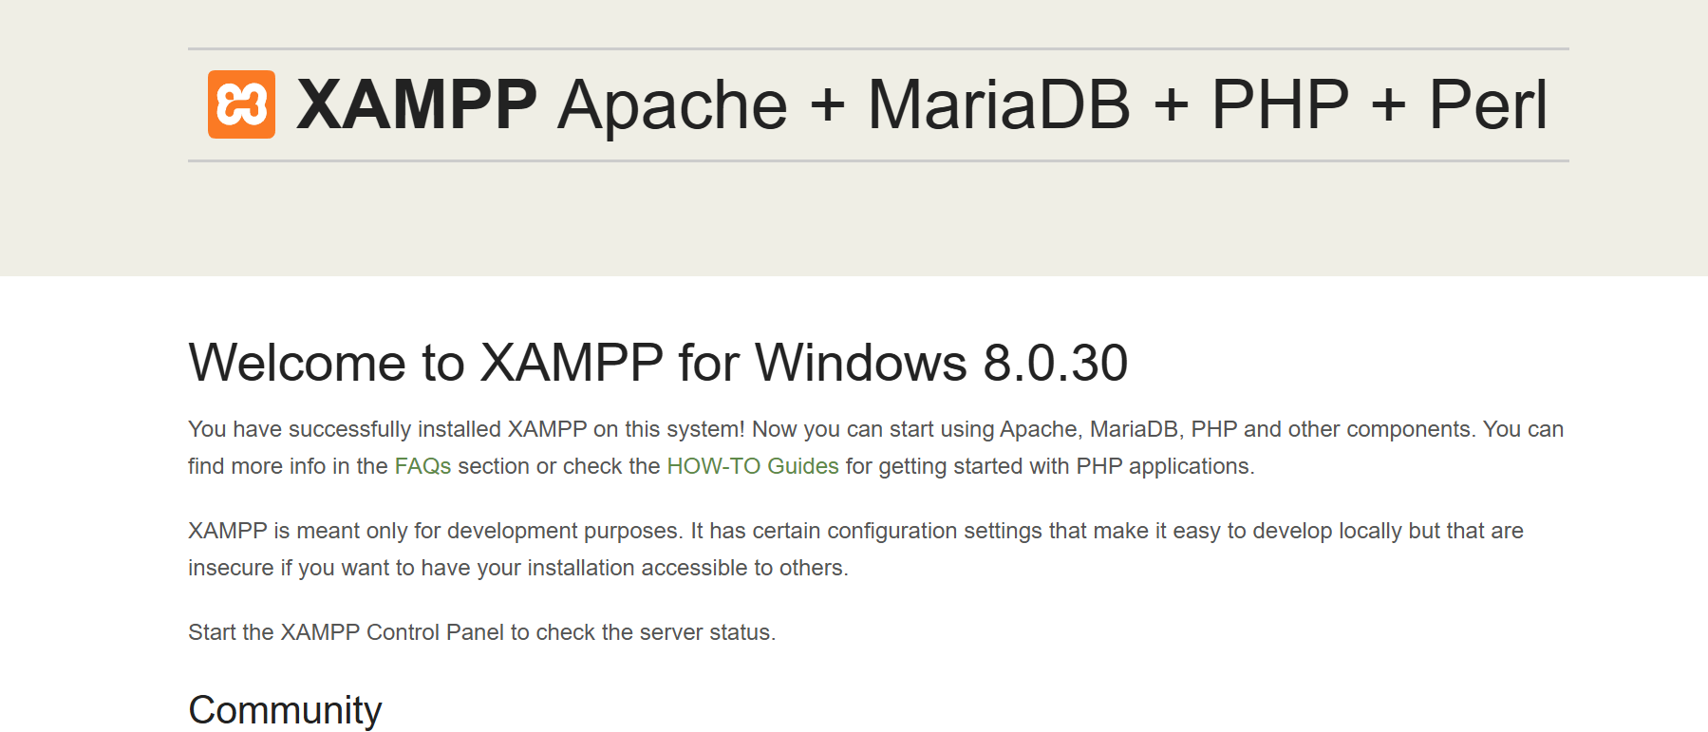
- Fig 4: PHP Hello World Test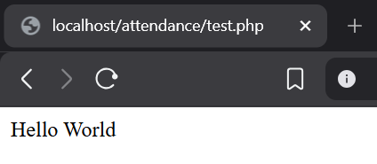
- Fig 5: PHP script output confirming a successful database connection usingmysqli_connect() to a MySQL database,
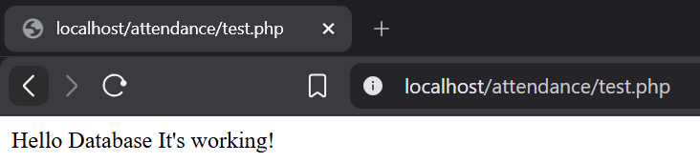

Student Reflection
During this week, I installed XAMPP to create a local development environment and learned how localhost enables testing of PHP applications without online hosting. I used XAMPP, Apache, MySQL, and PHP. One challenge was resolving port conflicts to ensure Apache and MySQL services ran correctly. Figure 5 shows a successful database connection using mysqli_connect(), confirming communication between PHP and MySQL, which is essential for the Supplier Verification System's database operations

Week 2: Wireframes and GUI Design

Title
User Interface Planning and System Design

Required Evidence
- Fig 1: Hand-drawn wireframe of the system homepage
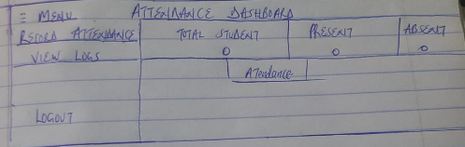
- Fig 2: Attendance dashboard layout design

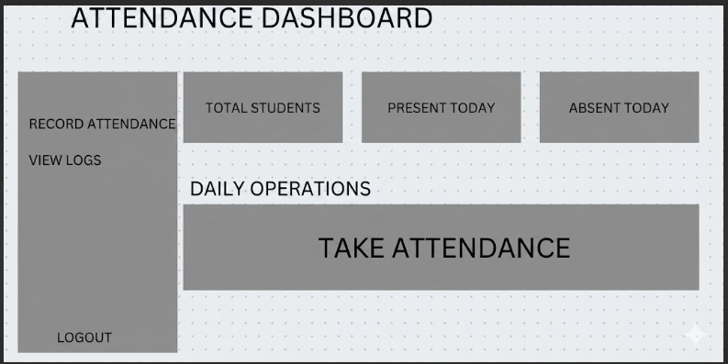
- Fig 3: Mobile view mockup demonstrating a responsive homepage layout
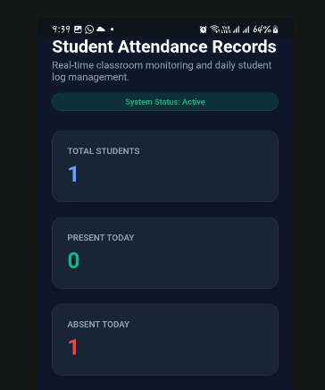
- Fig 4: Color theme and navigation structure screenshot showing the selected color palet
- 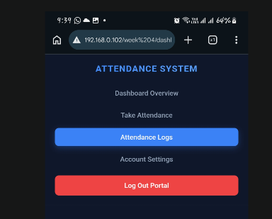
- Fig 5: GUI Prototype in Draw.io

- 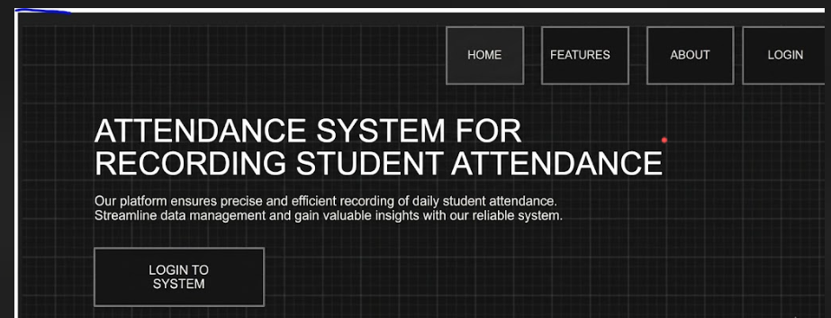

Student Reflection
. The homepage and dashboard were designed to provide instructors and system administrators with easy access to daily student attendance records and classroom logs. A left-side navigation menu was used to support future system expansion, while a professional color scheme was chosen to improve usability and reduce visual clutter. Mobile responsiveness was incorporated from the start to ensure accessibility across different devices. The mobile mockups demonstrated the planned responsive design, and the wireframes provided a clear structure that guided the frontend development process.

Week 3: JavaScript and PHP Basics

Title
Frontend Interaction and Backend Foundations

Required Evidence
- Fig 1: Login form
- 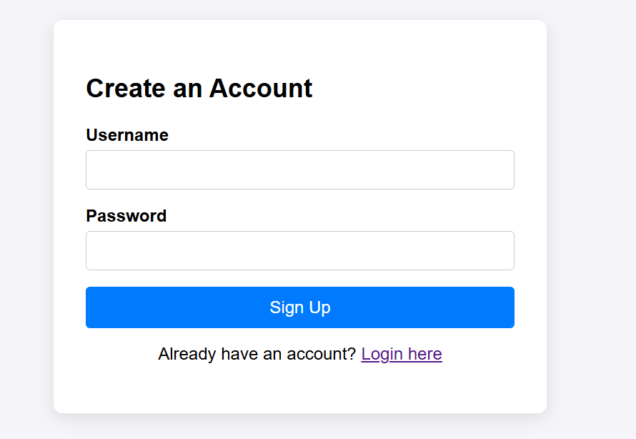
- Fig 2: Password strength checker output
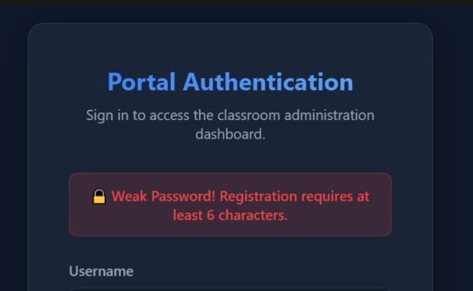
- Fig 3: PHP syntax practice file open in VS Code, showing basic PHP variables, conditional statements, and output functions used as a foundation for backend logic.
- 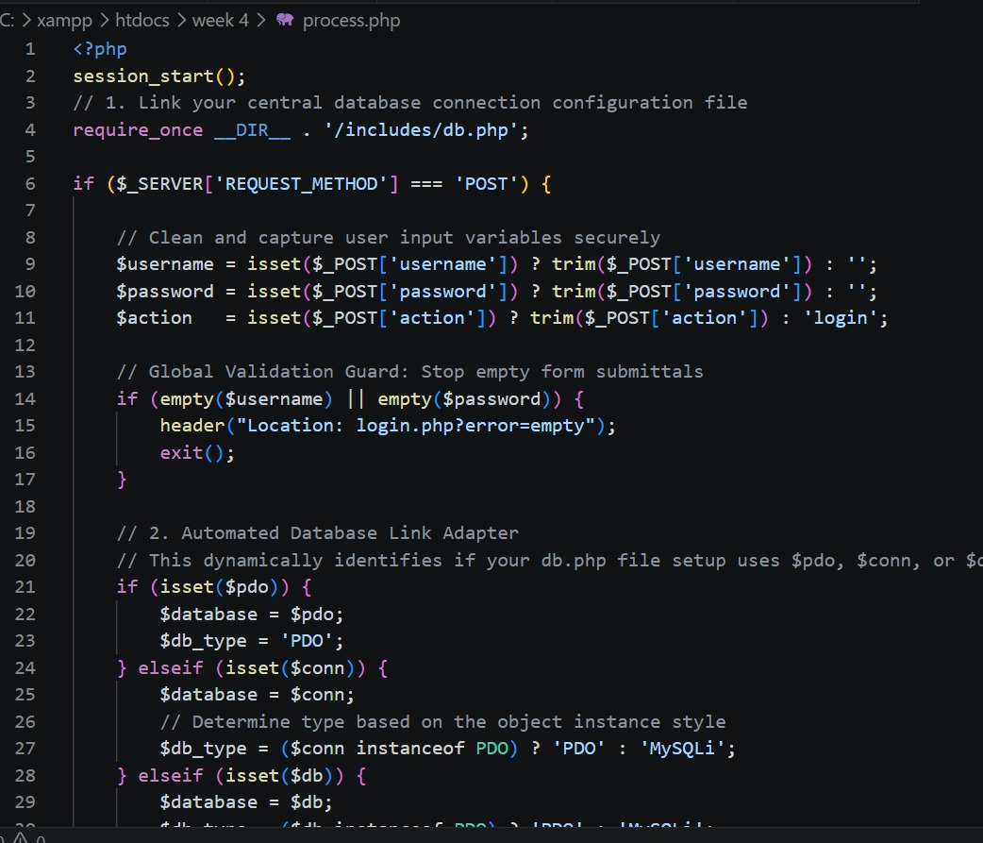
- Fig 4: db_connect.php file showing the mysqli connect() function with the correct database credentials, confirming that a reusable database connection script has been created for use across system pages.
- 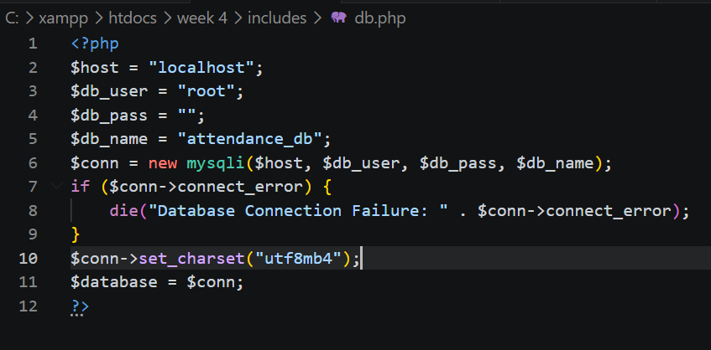
- Fig 5: Dynamic User Input Handling
- 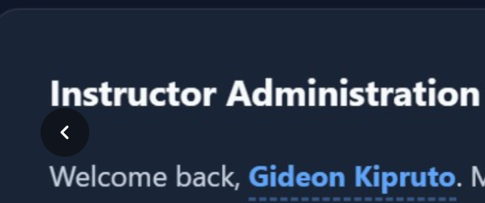

Student Reflection
JavaScript was used for frontend form validation to provide immediate user feedback and reduce unnecessary server requests. PHP handled backend processing of submitted data, while the database connection in Figure 4 ensures consistent access to MySQL records. A key challenge was distinguishing between client-side validation (browser-based) and server-side processing (on the server), which is important because client-side checks can be bypassed, requiring additional PHP validation for security

Week 4: Server-Side Components

Title
PHP Authentication and Session Management

Required Evidence
Fig 1: Admin user registration page
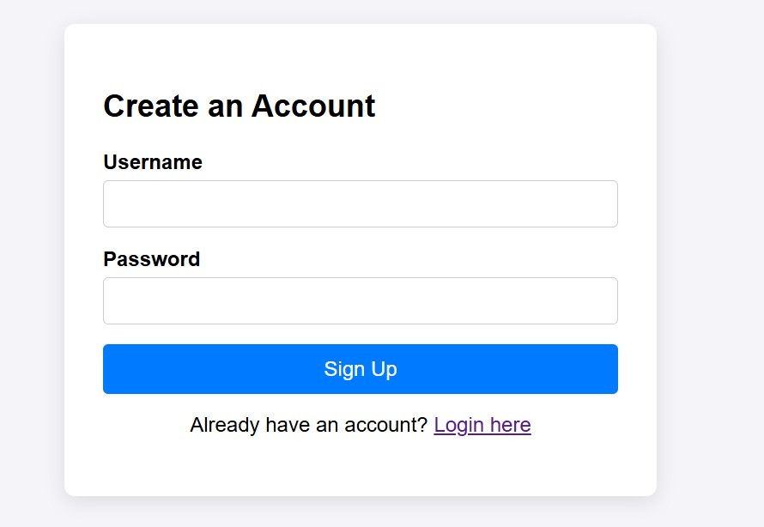
Fig 2: Login page
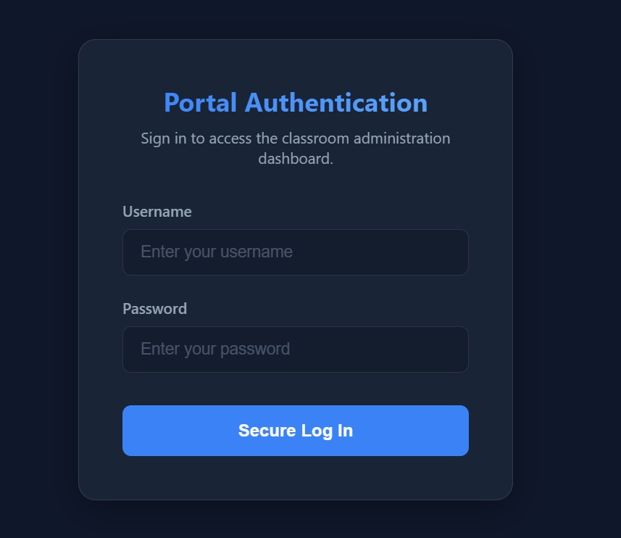
- Fig 3: Password hashing
- 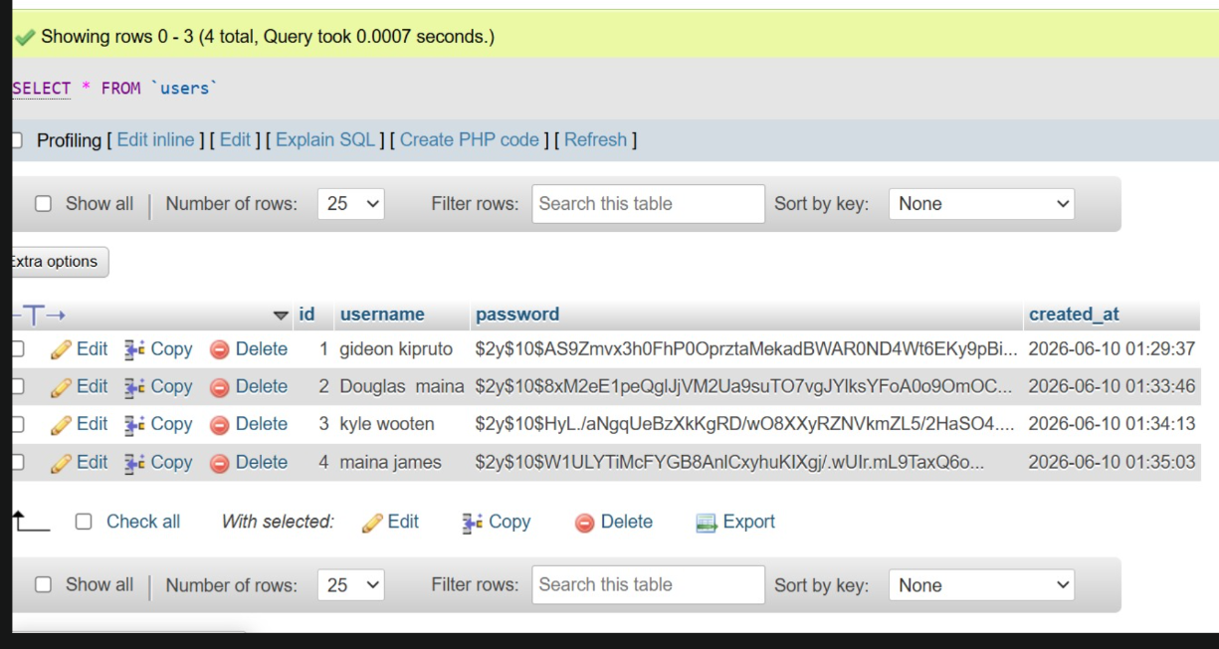
- Fig 4: Admin dashboard
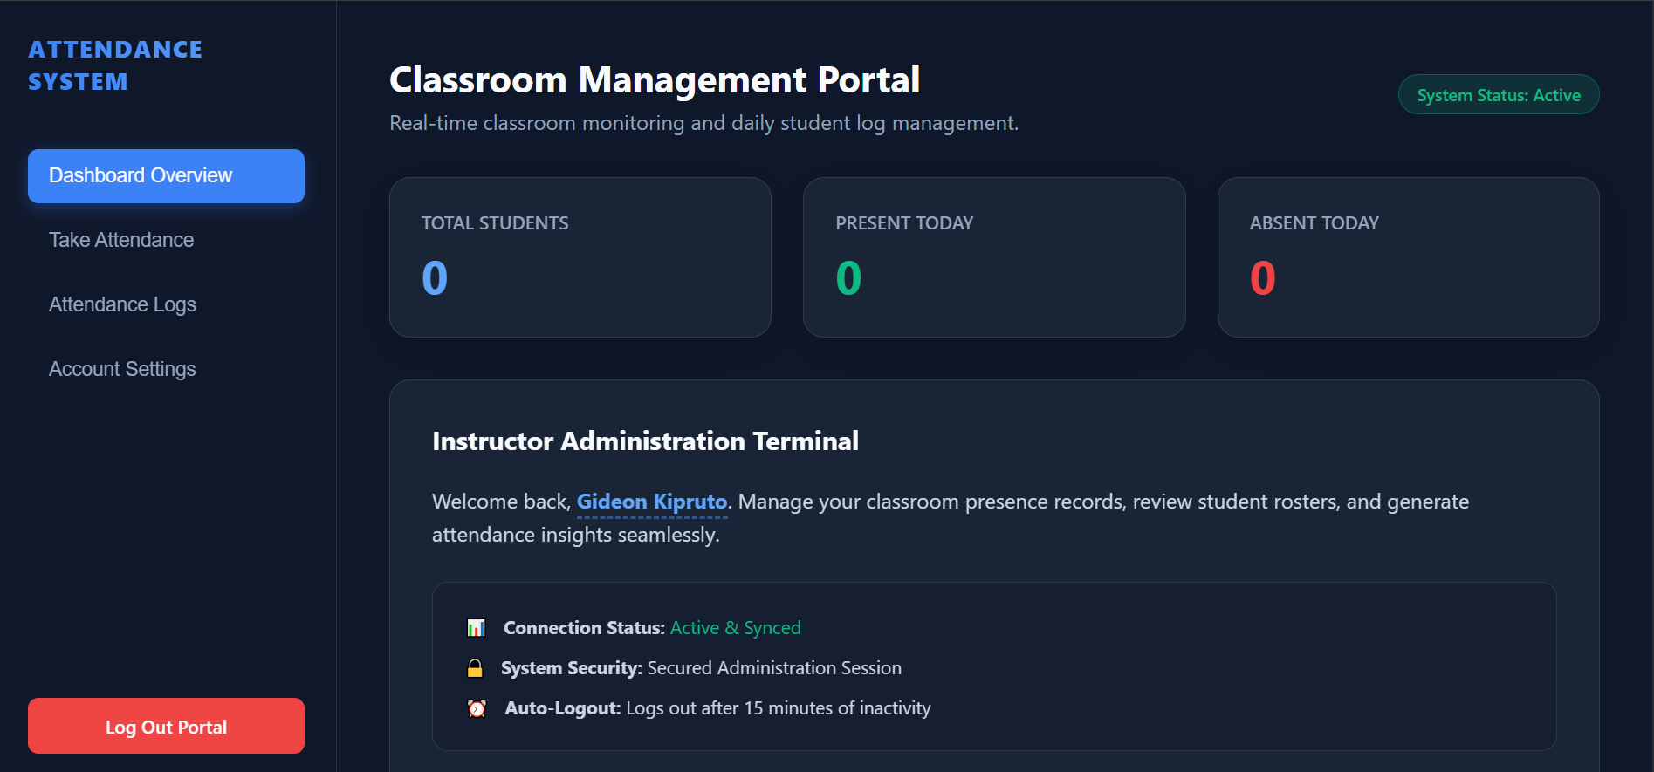
- Fig 5: task attendance dashboard
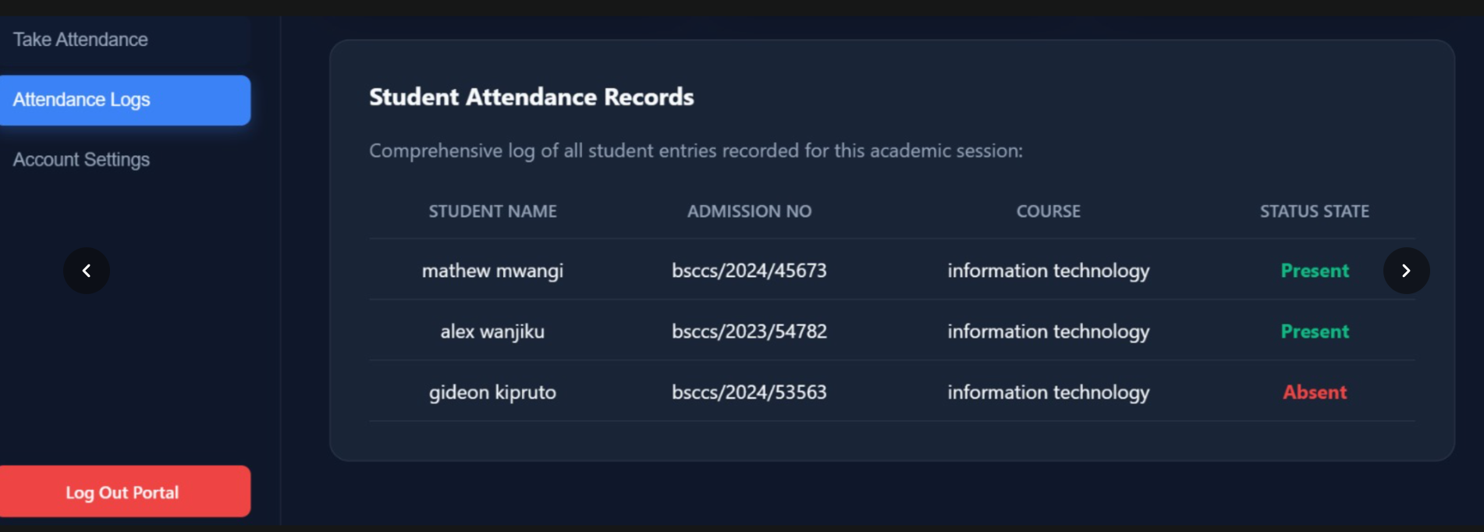
- Fig 6: session_check.php file open in VS Code
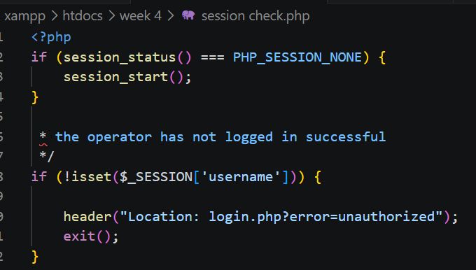

Student Reflection
This week focused on building the authentication layer of the Attendance System. PHP sessions were used to maintain user login state across pages, so once a user logs in, their identity is remembered until they log out or the session expires. Password hashing using password_hash() was implemented to ensure that even if the database is compromised, actual passwords cannot be recovered directly. A challenge encountered was implementing role-based access correctly so that admins and procurement officers see different dashboards after login. Fig 6 shows the session_check.php script which is included at the top of every protected page to redirect unauthenticated users back to the login page.

Week 5: Database Components

Title
This project implemented a PHP and MySQL system demonstrating CRUD operations and login integration. Users can create, read, update, and delete records in the database. The system also includes secure login authentication, form validation, and database connectivity, showing effective interaction between the frontend, PHP processing, and backend database management.

Required Evidence
Fig 1: Database 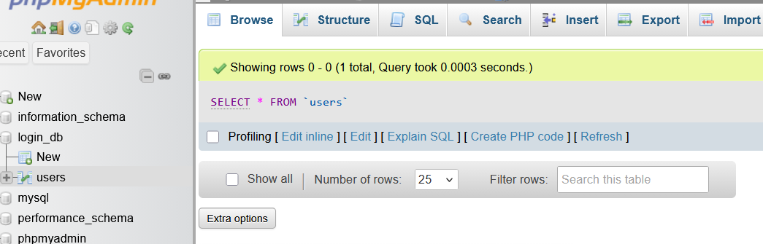
Fig 2: Attendance table structure.
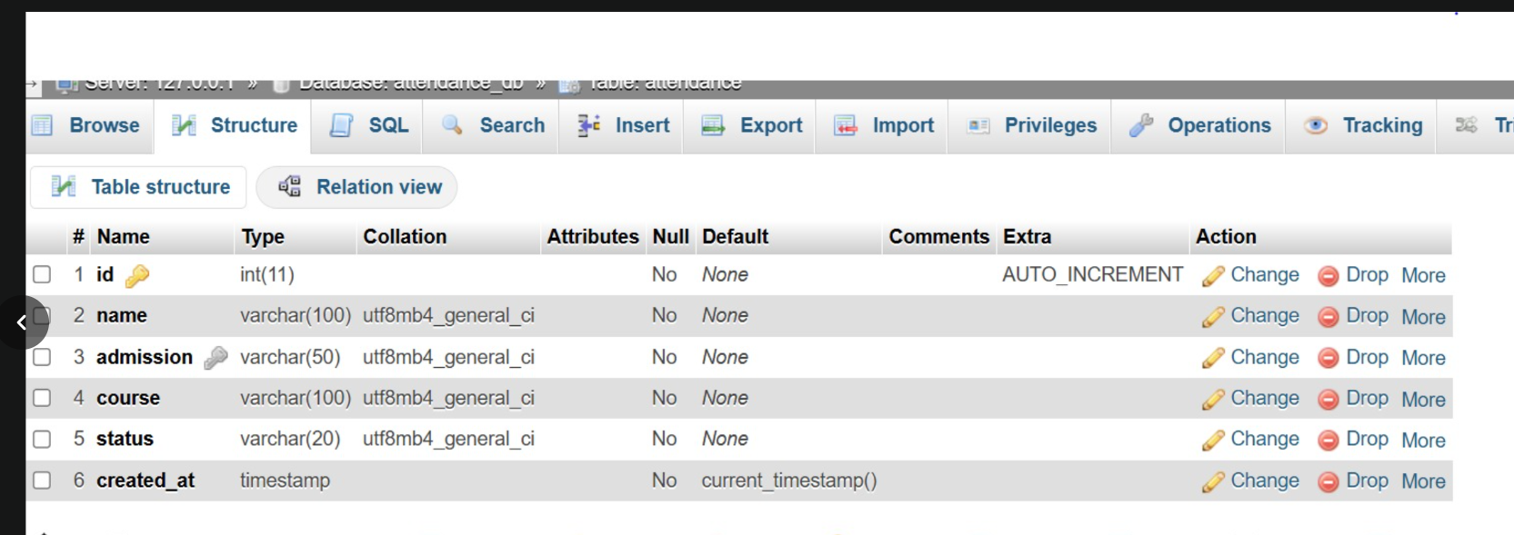
Fig 3: User table structure.
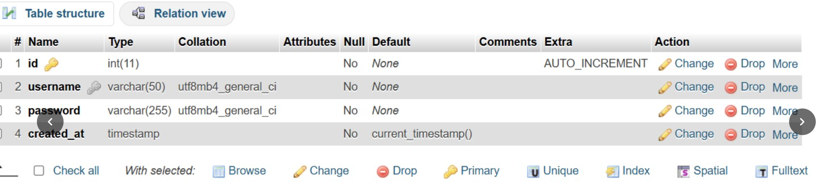

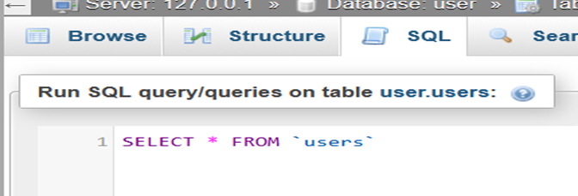
Fig 4: delete
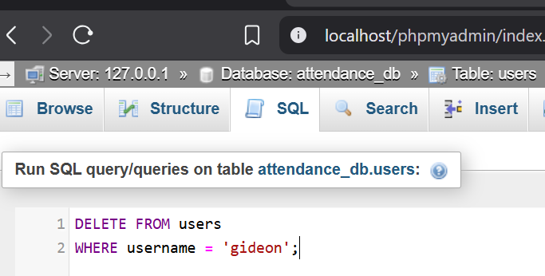
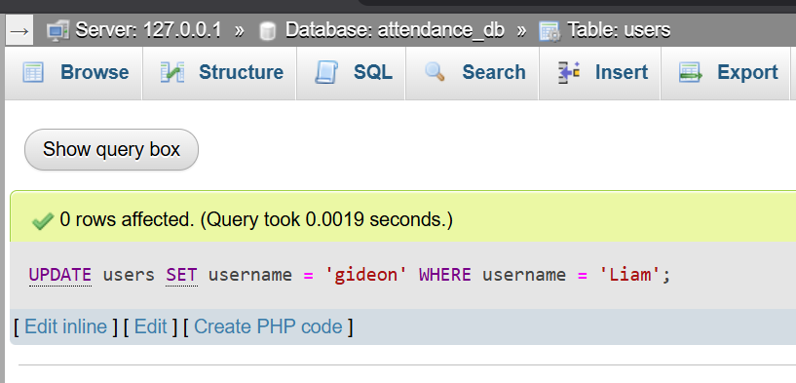
.

Student reflection
This week focused on building the authentication layer of the attendance System. PHP sessions were used to maintain user login state across pages, so once a user logs in, their identity is remembered until they log out or the session expires. Password hashing using password_hash() was implemented to ensure that even if the database is compromised, actual passwords cannot be recovered directly. A challenge encountered was implementing role-based access correctly so that admins and procurement officers see different dashboards after login

